NAMA : Taufiq Hidayah

NIM : 2101720902

=====================================================================================

Network Programming

Screenshot

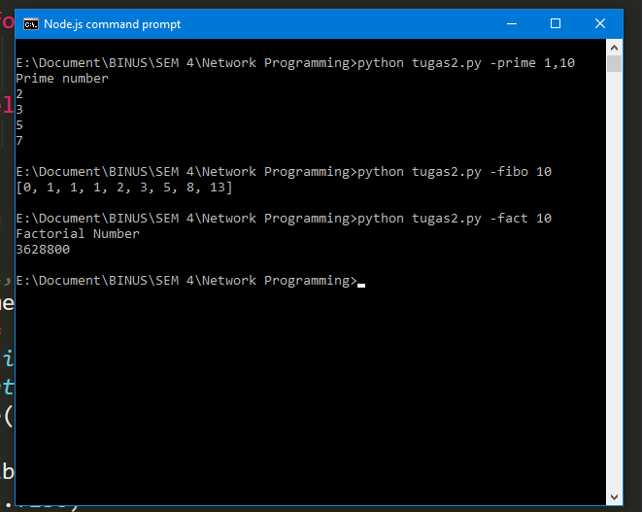

Code :

|  |
| --- |
| import argparse  parser =argparse.ArgumentParser(description='Calculate of task')  parser.add_argument('-prime','--prime', metavar='', help='Prime number format : ')  parser.add_argument('-fact','--fact',type= int, metavar='',help='Factorial number format : number')  parser.add_argument('-fibo','--fibo',type= int,metavar='', help='Fibonaci number format : number')  args = parser.parse_args()  def fib(n):  a, b = 0, 1  result = [0, 1]  while a < n:  result.append(b)  a, b = b, a+b  print result  def fact(n):  print("Factorial Number")  times=1  for x in range(1,n+1):  times = times *x  return times    # fact(10)  def is_prime(awal,akhir):  # lista =[]  print("Prime number")  for val in range(awal, akhir + 1):  if val > 1:  for n in range(2, val):  if (val % n) == 0:  break  else:  print (val)  # lista.append(val)  # return lista  # is_prime(1,10)  if args.prime:  result = args.prime.split(',')  star = int(hasil[0])  end = int(hasil[1])  is_prime(star,end)  elif args.fibo:  fib(args.fibo)  elif args.fact:  print fact(args.fact) |